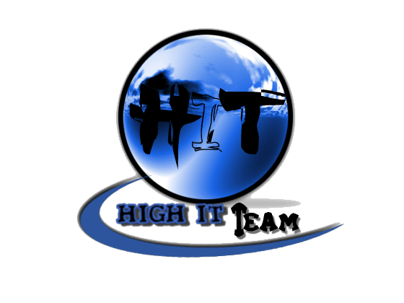
Team Assignment 05
HIT
3/17/2012

Software Measurement and Analysis

Team members: | Members ID
Giang Thị Ha Thanh | T097828
Trần Dũng Đạt | T095716
Nguyễn Vũ Trọng Giang | T096656
Huỳnh Chấn Huy | T096498
Tạ Quang Hiệp | T090363
Nguyễn Trần Hồng Phúc | T095014

Each team creates a high level network diagram, high level wbs and high level schedule for the Viking project.
WBS Dictionary
The WBS Dictionary contains all the details of the WBS which are necessary to successfully complete the project. Most importantly it contains a definition of each Work Package which can be thought of as a mini scope statement. Resources on the project will look at the WBS dictionary to determine the scope of the Work Package they've been assigned, so it's important to be clear when writing the definition.

Level | WBS Code | Element’s name | Definitions
1 | 1.1 | Planning | Prepare for project, establish schedule
1 | 1.1.1 | Produce basic Schedule
2 | 1.1.2 | Training team
3 | 1.1.2.1 | Understand deeply RUP
3 | 1.1.2.2 | Apply RUP to team
2 | 1.1.3 | Open Team Meeting
3 | 1.1.3.1 | Define Team Roles ad Responsibility
3 | 1.1.3.2 | Define Team Goals
3 | 1.1.3.3 | Measure Team Goals
3 | 1.1.3.4 | Define Team Member Goals
3 | 1.1.3.5 | Measure Team Goals
3 | 1.1.3.6 | Measure Team Member Goals
1 | 1.2 | Kick-off | Agreement with customer about schedule, role of project team….
2 | 1.2.1 | Review Requirements
2 | 1.2.2 | Develop Strategy for Viking
1 | 1.3 | Inception & Elaboration | Deliverables contain whatever workflows are necessary to get the stakeholders to agree on the objectives, rough architecture, and rough schedule of the project.
2 | 1.3.1 | Produce User Requirement | Developers and Customer have a shared understanding of the system
3 | 1.3.1.1 | Identify and describe Use-Case
3 | 1.3.1.2 | Refine, review and acquire Requirements Document Sign-off
2 | 1.3.2 | Produce Viking Architecture Document
3 | 1.3.2.1 | Document architectural specifications
3 | 1.3.2.2 | Document Constrains
2 | 1.3.3 | Produce Project Charter | Document agreement among stakeholders, iterating until charter is approved by President
2 | 1.3.4 | Produce Project Plan | Document Plans and submit to peers for inspection to identify defects. Modify plans based on results of inspection. Submit updated plans to Project Manager for review/approval.
1 | 1.4 | Elaboration | - tighten up the architecture and plan  - discover the rest of the use cases
2 | 1.4.1 | Develop High Level Design Document
3 | 1.4.1.1 | Discover the rest of the use-case
3 | 1.4.1.2 | Document Use Classes
3 | 1.4.1.3 | Document Graphical User Interface Specifications
2 | 1.4.2 | Develop Detailed Level Design Document
3 | 1.4.2.1 | Document User Cases to be developed
2 | 1.4.3 | Produce Test Plan (Unit Test and Integration Test) | Plan for testing Project Module and  completed test results
3 | 1.4.3.1 | Document Plans
3 | 1.4.3.2 | Submit to peers for inspection
3 | 1.4.3.3 | Modify plans based on the result of inspection
3 | 1.4.3.4 | Submit updated plans to PM
1 | 1.5 | Construction | Work towards giving the customer the minimum system that they need. The natureof the iterations won't change much, but the focus will be on identifying the smallest possible deliverable that will still meet at least some of the customers’ needs. During construction, the use cases will change as the customer sees the growing system and feeds refinements back to the project.
2 | 1.5.1 | Produce Viking module Construction
3 | 1.5.1.1 | Module- Communication
3 | 1.5.1.2 | Module- Reports
3 | 1.5.1.3 | Module- Synchronization
3 | 1.5.1.4 | Module- Time Accounting Interface
3 | 1.5.1.5 | Module-PDA Interface
3 | 1.5.1.6 | Module-User Definable Items
2 | 1.5.1 | Package the deliverables
2 | 1.5.2 | Address the work package
2 | 1.5.3 | Adding functionality in each subsequent work package
2 | 1.5.4 | Test work package | Test each work package against the specific requirements documented in the URD that the work package was defined to address.
3 | 1.5.4.1 | Implement Unit Test
3 | 1.5.4.2 | Implement Integration Test
3 | 1.5.4.3 | Validation
1 | 1.6 | Transition | Refine the functionality of the system, by incorporating customer feedback. The use cases are likely to undergo further refinements as the customers actually use the system and discover exactly what they need.
2 | 1.6.1 | Perform acceptance testing | on the stand alone product, based on URD, HLD, DD, and architectural specifications.
3 | 1.6.1.1 | Incorporating customer feedback
3 | 1.6.1.2 | Refine the functionality
2 | 1.6.2 | Produce Viking Training Material
3 | 1.6.2.1 | Make Viking User Guide | User Guide to support the use of Viking
3 | 1.6.2.2 | Make Viking Training | Training materials to support the use of Viking
2 | 1.6.3 | Produce Viking Product Documentation | Document that contains product information for the administration of Viking
1 | 1.7 | Close-out
2 | 1.7.1 | Perform Final Review
3 | 1.7.1.1 | Final Review of the Viking Product
3 | 1.7.1.2 | Review Associated Product Documentation
3 | 1.7.1.3 | Review training materials and User Guide
2 | 1.7.2 | Consume Lessons Learned
3 | 1.7.2.1 | Document insights from the project, problems
3 | 1.7.2.2 | Document how they were solved
3 | 1.7.2.3 | Document other information worthy of passing on to Steering Committee and future project teams
2 | 1..7.3 | Produce Project Close-out document
3 | 1.7.3.1 | Document the closure of the project
3 | 1.7.3.2 | Confirms the delivery of the product
3 | 1.7.3.3 | Release the resources

